Sandra at the u3a Conference
This was held at York university campus. I was so busy going from workshops to lectures, doing 2 stints as a steward and relaxing watching the different genres in the concert hall.
Workshops I took part in slow stitching and floral crown making.
Lectures gardening with wildlife, AI for everyone, The Antivaxxers history of anti-vaccination,
Music u3a Wetherby guitar group, u3a Wakefield recorder group, u3a Whitby whaler band, and a Open Mic session.
Also Night Sky walk, dance exercise and retired from pickleball through thumb injury.
Three and half hour's (2 sessions ) stewarding.

Everyone that I spoke to thoroughly enjoyed the festival. Except for the wildlife gardening everything was run by u3a members. I had a fabulous time.
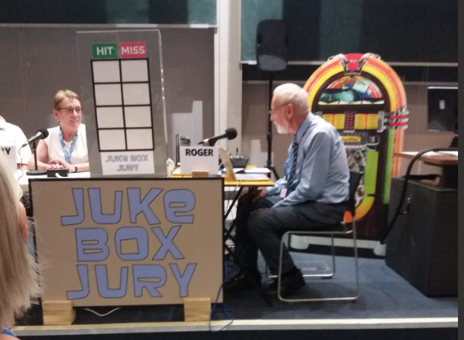
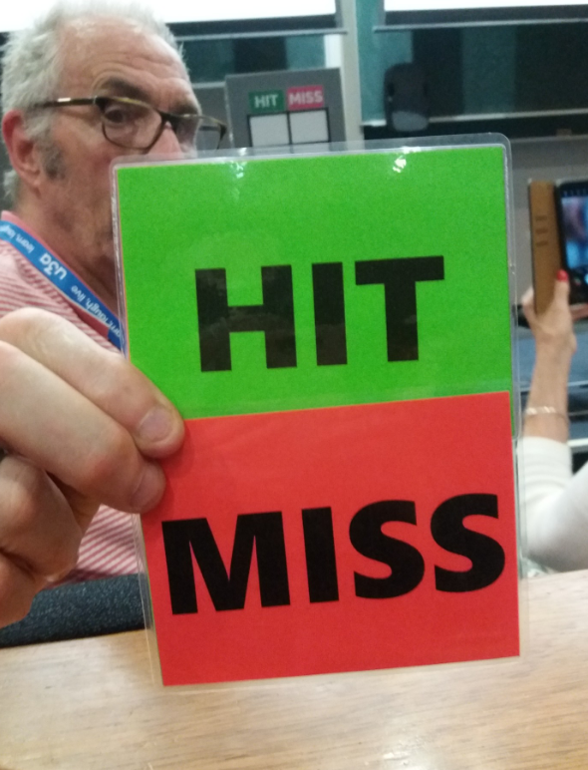
Juke box Jury
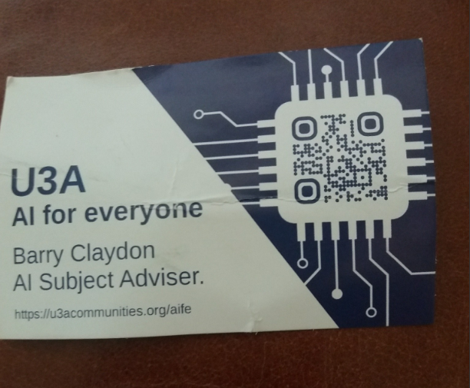
Followed by The Antivaxxers, History of Anti-Vaccination. Who knew Florence Nightingale was one of them.
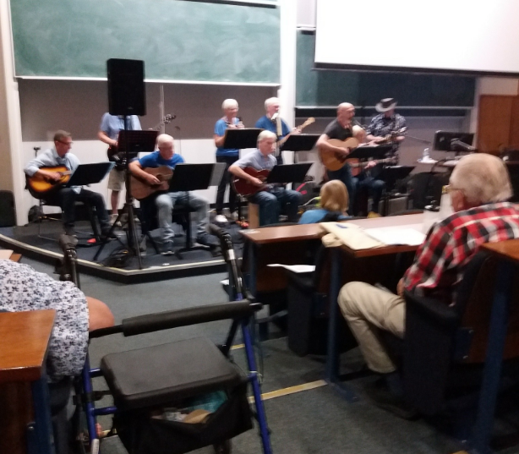 Wetherby guitar group
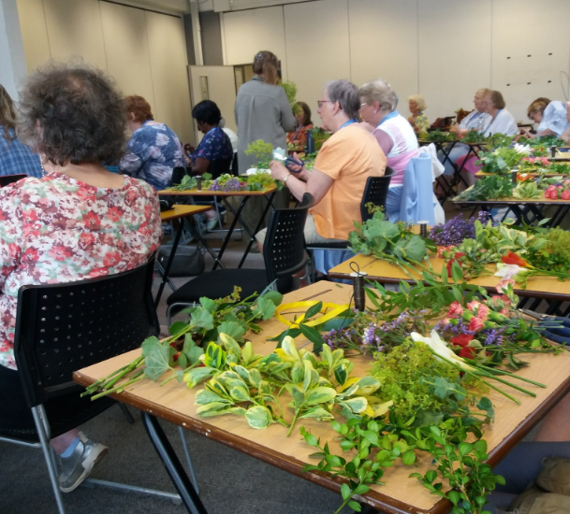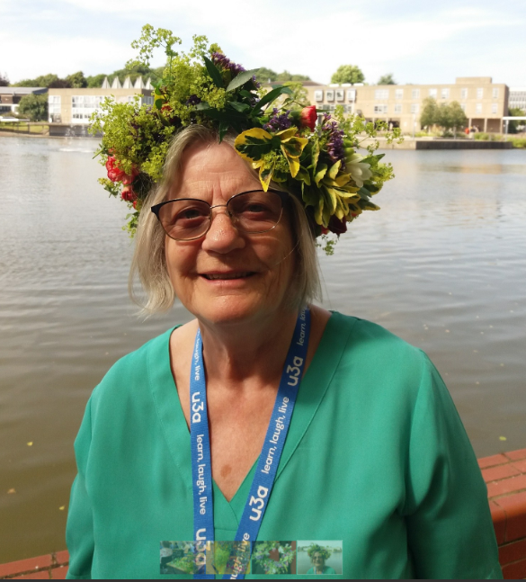
Floral crown workshop

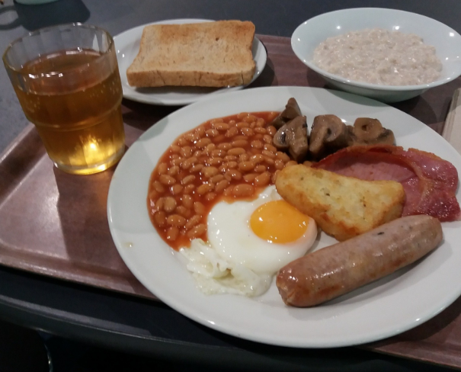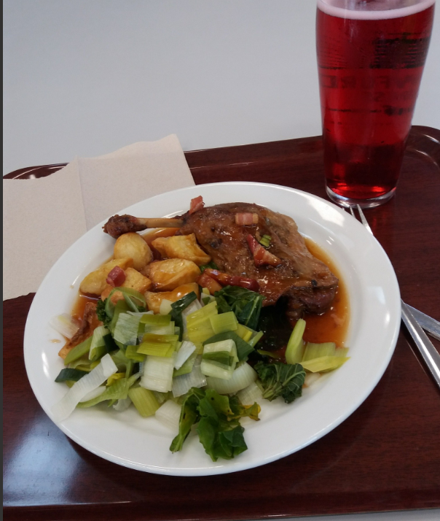
Breakfast Dinner Duck confit

